THE OXFORD COLLEGE OF ENGINEERING (TOCE)
DEPARTMENT OF INFORMATION SCIENCE & ENGINEERING
1st Project Review PPT Content — Agenda Point 6: Modules, Algorithms & Formulations
――――――――――――――――――――――――――――――――――――――――――――――――
SLIDE PRESENTATION CARD | AGENDA POINT 6
SLIDE 1: SYSTEM MODULES BREAKDOWN OVERVIEW
Agenda Point 6.1 — Core Architectural Modules

- Module 1: Dataset Ingestion & 3-Class Parser (src/data/dataset_parser.py) — Parses raw Kaggle binary folders into Class 0 (Normal: 1,583), Class 1 (Bacterial: 2,780), and Class 2 (Viral: 1,493) across 5,856 radiographs.
- Module 2: OpenCV CLAHE Contrast Engine (src/data/clahe.py) — Executes 8x8 tile grid adaptive histogram equalization with clip limit beta=2.0 to standardize inter-equipment lighting variations.
- Module 3: PyTorch Biomedical U-Net Lung Segmentation (notebooks/colab_lung_segmentation_unet.py) — Isolates lung parenchyma ROI and eliminates extra-pulmonary shortcut artifacts (Dice: 0.956, IoU: 0.898).
- Module 4: 3-Class ResNet50 Deep Classifier (src/models/resnet_classifier.py) — Deep residual network trained with inverse class weighting and Albumentations MixUp/CutMix regularization.
- Module 5: Grad-CAM Explainable AI & Streamlit Web UI (src/utils/gradcam.py & app.py) — Generates Layer 4 gradient heatmap overlays and presents an interactive clinical triage dashboard.
🎙️ SPEAKER NOTES FOR PRESENTATION: Emphasize to the review panel that Modules 1, 2, and 3 are 100% completed (~60% project milestone), while Modules 4 and 5 represent the remaining implementation phase.

SLIDE PRESENTATION CARD | AGENDA POINT 6
SLIDE 2: ALGORITHM 1 — CLAHE CONTRAST ENGINE
Contextual Local Contrast Standardization & Clipping

- Objective: Amplify subtle ground-glass opacities without over-saturating homogeneous chest regions.
- Grid Processing: Divides CXR images into 8x8 non-overlapping contextual tiles.
- Mathematical Clipping: Limits local histogram height at beta=2.0 and redistributes excess pixels uniformly.
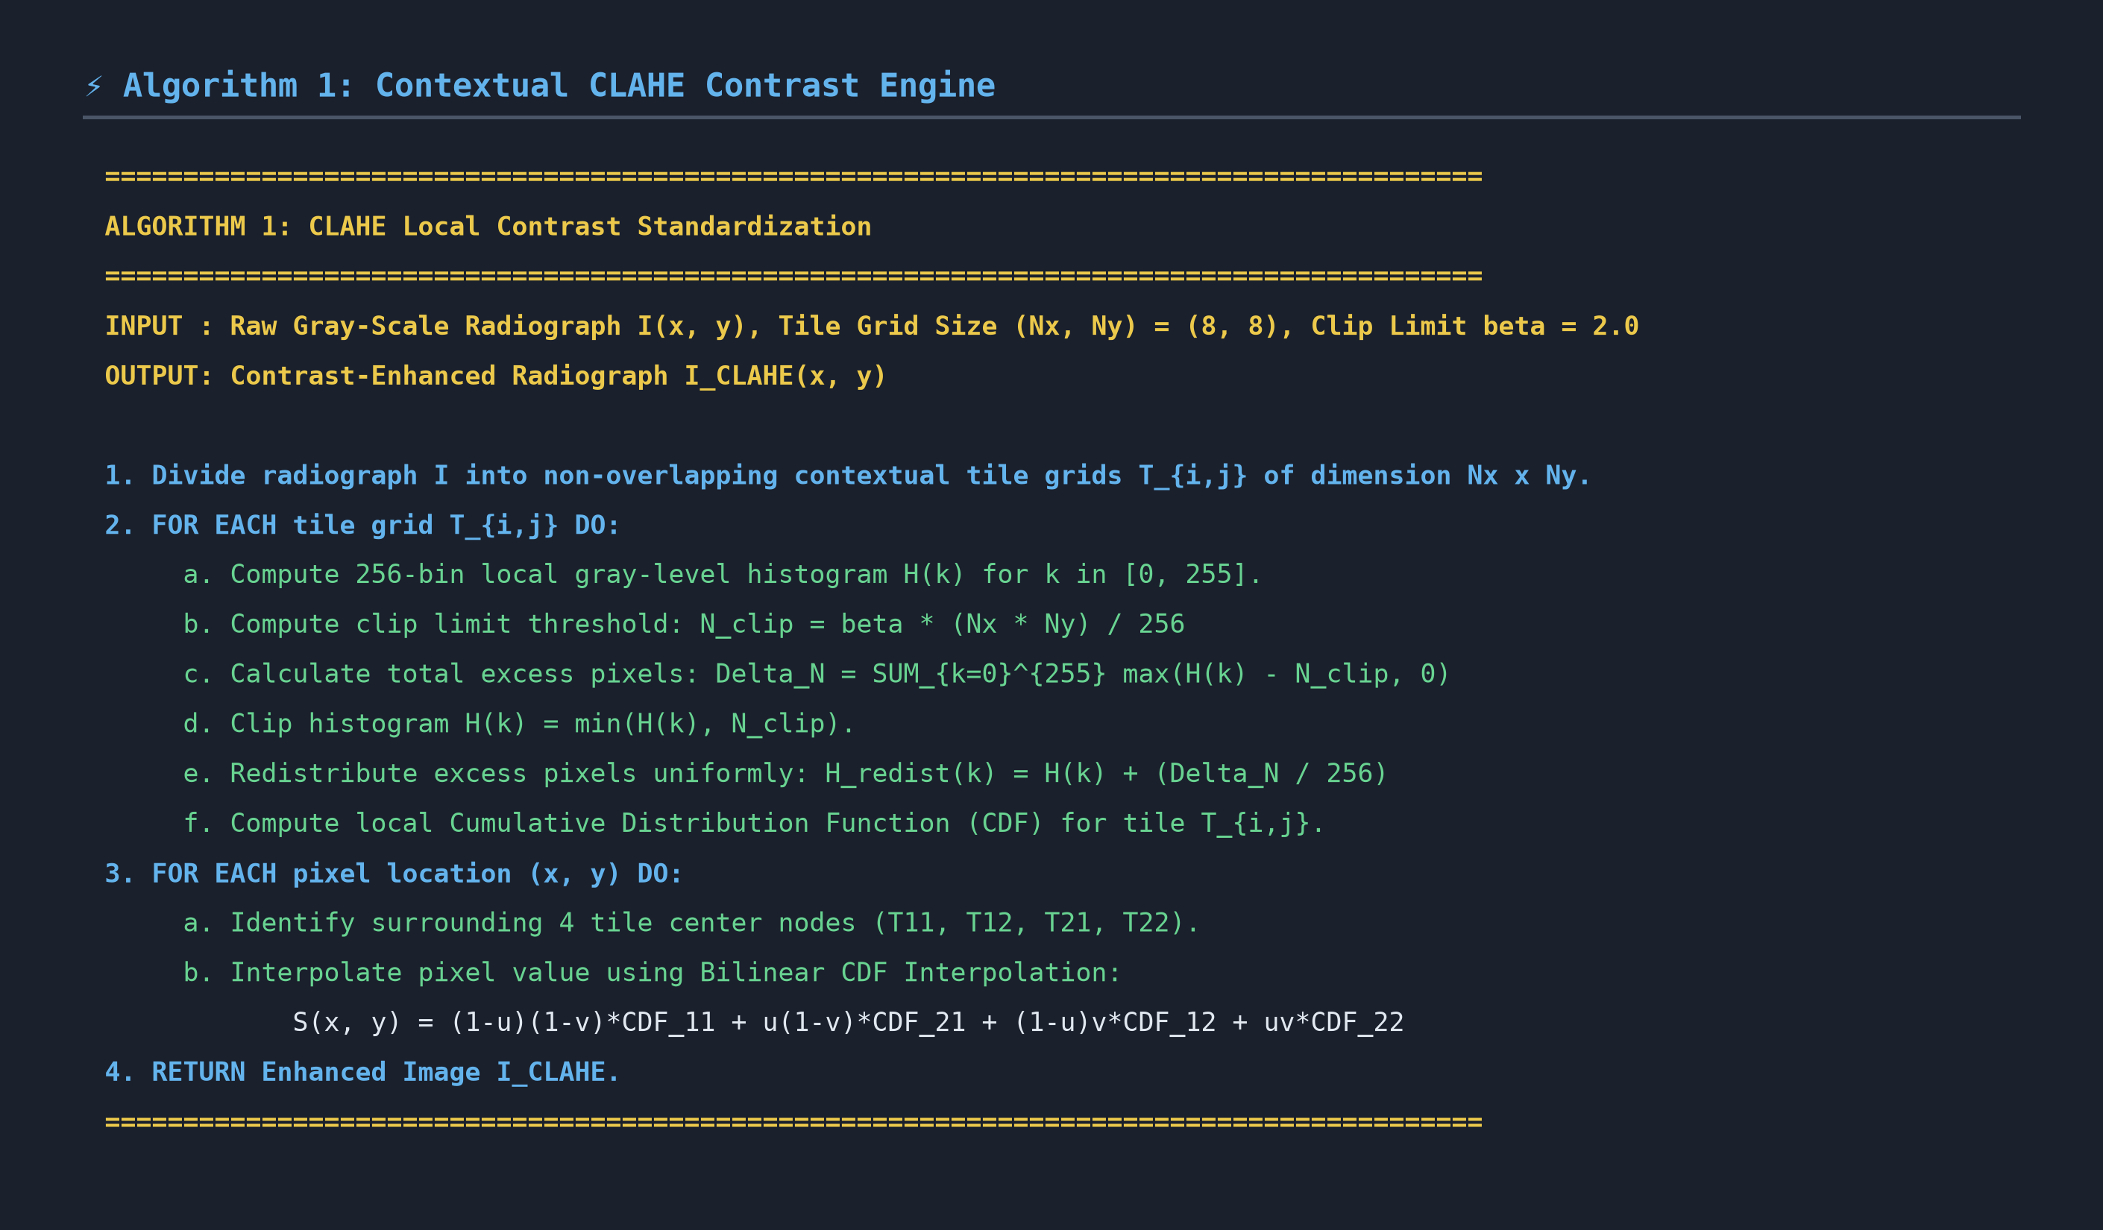
Photo 1.1: High-Resolution Pseudocode Photo — Algorithm 1 (CLAHE Enhancement Engine)

Photo 1.2: Rendered Mathematical Formula Photo — CLAHE Clip Limit & Bilinear Interpolation
🎙️ SPEAKER NOTES FOR PRESENTATION: Explain that global histogram equalization destroys CXR details. CLAHE clips tile histograms at beta=2.0, spreading excess pixel counts evenly so soft-tissue infiltrates become visible.

SLIDE PRESENTATION CARD | AGENDA POINT 6
SLIDE 3: ALGORITHM 2 — U-NET SEMANTIC LUNG SEGMENTATION
Anatomical ROI Isolation & Black-Box Overfitting Prevention

- Objective: Extract precise lung parenchyma boundaries and discard peripheral extra-pulmonary shortcut artifacts.
- Architecture: Contracting Encoder + Bottleneck + Expanding Decoder with residual skip connections.
- Loss Optimization: Trained with combined DiceBCELoss to achieve Dice Coefficient = 0.956.
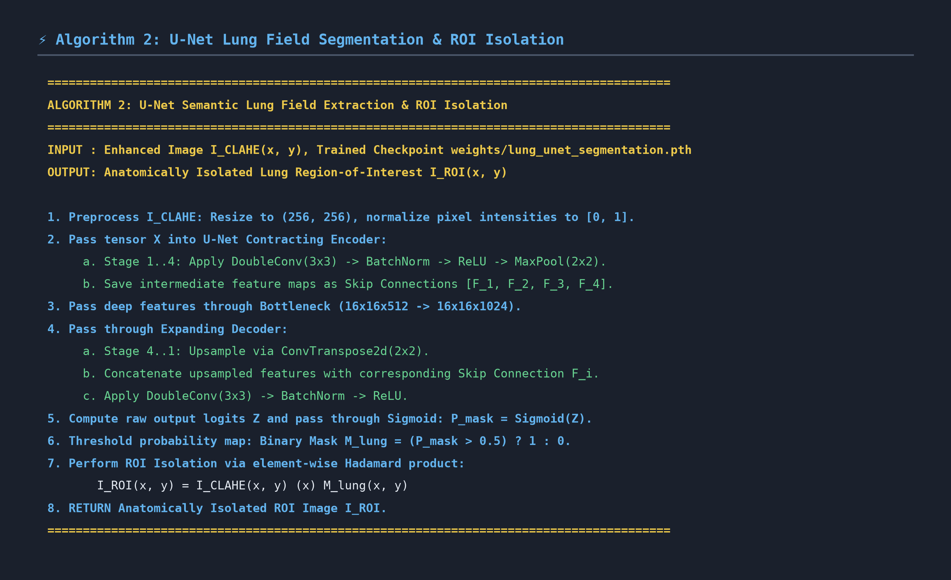
Photo 2.1: High-Resolution Pseudocode Photo — Algorithm 2 (U-Net Semantic Lung Field Extraction)

Photo 2.2: Rendered Mathematical Formula Photo — Combined DiceBCELoss & Dice Similarity Metric
🎙️ SPEAKER NOTES FOR PRESENTATION: Highlight that skip connections directly pass high-resolution spatial feature maps from encoder to decoder, preventing loss of fine costal and apical lung margins.

SLIDE PRESENTATION CARD | AGENDA POINT 6
SLIDE 4: ALGORITHM 3 — RESNET50 3-CLASS CLASSIFIER
Transfer Learning, Class Weighting & MixUp Augmentation

- Objective: Classify isolated lung ROIs into Normal (Class 0), Bacterial (Class 1), or Viral (Class 2).
- Imbalance Resolution: Applies inverse class frequency weighting (w_Normal=1.23, w_Bacter=0.70, w_Viral=1.31).
- Regularization: Utilizes Albumentations MixUp (lambda ~ Beta(0.2, 0.2)) to force smooth decision boundaries.
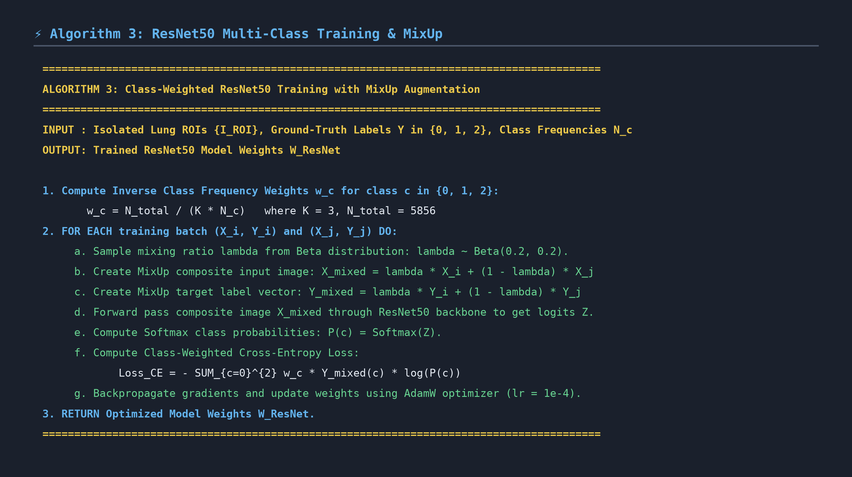
Photo 3.1: High-Resolution Pseudocode Photo — Algorithm 3 (ResNet50 Training & MixUp)

Photo 3.2: Rendered Mathematical Formula Photo — Inverse Class Frequency Weighting & MixUp Math
🎙️ SPEAKER NOTES FOR PRESENTATION: Note that Bacterial cases account for 47.5% of dataset images. Class weighting ensures the neural network treats Viral and Normal cases with equal diagnostic importance.

SLIDE PRESENTATION CARD | AGENDA POINT 6
SLIDE 5: ALGORITHM 4 — GRAD-CAM EXPLAINABILITY
Gradient Localization & Clinician Visual Heatmaps

- Objective: Provide visual proof of diagnostic features for attending radiologists to establish AI transparency.
- Gradient Pooling: Computes Global Average Pooling (GAP) of backpropagated gradients over Layer 4 feature maps.
- ReLU Filtering: Applies Rectified Linear Unit activation to discard negative gradients and retain positive lesion evidence.
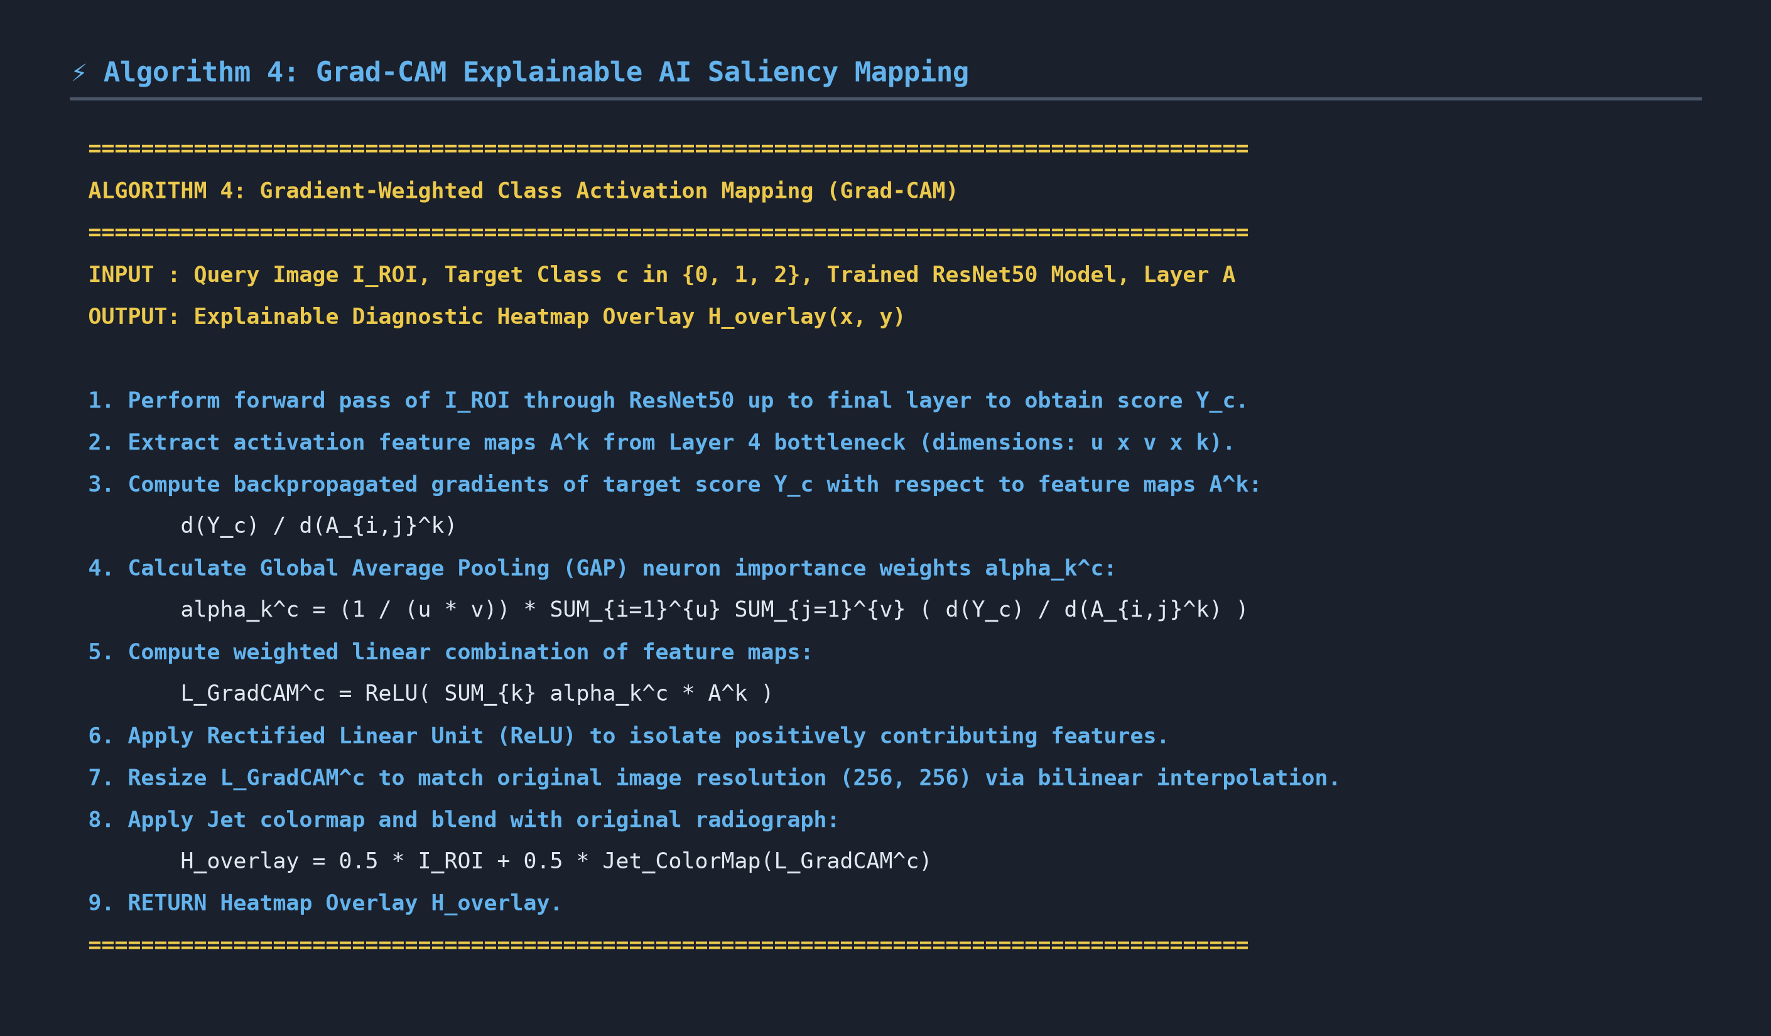
Photo 4.1: High-Resolution Pseudocode Photo — Algorithm 4 (Grad-CAM Saliency Map Generation)
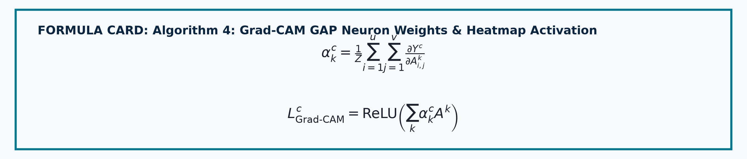
Photo 4.2: Rendered Mathematical Formula Photo — Grad-CAM GAP Weights & Heatmap Activation
🎙️ SPEAKER NOTES FOR PRESENTATION: Point out that applying ReLU in Grad-CAM is crucial because it isolates only those features that positively contribute to the target pneumonia class, filtering out irrelevant features.

